Welcome Club

March 12 2021~ 3:30pm-4:30pm

 Character lesson of the month:

Perseverance- using self-control

* Keep going, even when it’s hard
* STOP, THINK, and MAKE THE BEST DECISION

**3:30-3:35**

Introduction to Welcome Club  - (Coach Becca)

-Build friendships

-Help each other

-Discuss problems and issues with coaches and students

-Have fun!

 *Review Welcome club’s foundation for how we treat each other: Treat others the way you want to be treated.

-**Transition**- (Coach Colin) “Ok let’s have the coaches introduce themselves and tell us which cartoon character do you wish was real?” (Start with Makayla and Dani)

**3:35-3:45**

 Introduction of Coaches- We will take turns sharing our name and sharing which cartoon character we wish was real.

-**Transition**- (Coach Amy) “Now I want to introduce our lesson for today.” Self-control

Introduction of Character Lesson- Amy “Today we are going to talk about perseverance- self-control.

-**Transition**- (Coach Maddy) “Let’s get into our breakout rooms and we can start with a story challenge! Everyone make sure you have your Welcome Club bag and tape.”

**3:45-4:00**

- Coaches, start your group time by having each student introduce himself or herself. Next, you will need to explain the rules of the game. Assistant coaches are encouraged to participate. **Have students share what Emoji face they feel like today.**

ICEBREAKERS  - You choose story

Directions: Coach will read the provided story to the students. In the story the students will make decisions for the main character. Students can take turns or coach may let students shout out an answer for what the character should do. Assistant coaches- watch the chat box for students who are writing in their answers. See attached story.

**-Transition-** (coaches) “Abdul/Washma had some decisions to make at the park. He/She had some times when a tool to help keep in self-control would have been good to know. Let’s talk about self-control”.

**4:00-4:15**

 Lesson:    Perseverance- using self-control

Coaches:

“What is the definition of self-control? STOP, THINK, and MAKE THE BEST DECISION. Self-control helps us manage our thoughts, actions and emotions to get things done and be respectful of others. Is this easy to do? Is it easy to have self-control in our thinking, in our actions, or in our emotions? It takes time to develop self-control. Who can give us an example of having self-control in your actions? What about keeping your hands to yourself? In class has your teacher ever told you to keep your hands to yourself? Who can give us an example of having self-control in your emotions? What about when you have to wait for something?

Sometimes we feel like our emotions are ruling us or like we are a car and our emotions are driving us. But our emotions don’t always lead us in a way to make the best decision. Emotions are not bad but if we only do what we feel like doing and we don’t do what we know we need to do, we will hurt others and ourselves. Like when your teacher gives a math assignment but we don’t feel like doing math, you want to play video games. If you play video games and miss the math assignment what will happen to your grade? It will be a bad a grade and you won’t have success at school.

A tool to help us have self-control over our thoughts and emotions is to take a DEEP BREATH. We can breathe in through our nose like we are smelling a flower and blow out our mouth like we are blowing bubbles. This is a good tool to help us have self-control. Self-control takes time to work on. We all have to do our best and sometimes we forget to have self-control. The craft today will help us remember to take a deep breath, STOP, THINK, and MAKE THE BEST DECISION”.

Self-Control Examples if needed:

Self-control plays out in different ways, depending on the situation and setting kids are in.

* **In class:** Kids wait to be called on instead of blurting out answers. They take time to think about what the teacher said.
* **In social groups:** Kids handle joking without becoming outraged. They come up with better ways of responding instead of reacting.
* **In stores:** Kids keep from grabbing something they want off the shelf. They ask if they can see it or touch it.
* **At recess:** Kids wait their turn to use the slide instead of cutting in line. They might decide to use the swings instead.
* **At home:** Kids don’t interrupt conversations even when they’re dying to say something. They wait until the other person is done talking.

**Transition**- “In our story, the character (Abdul/Washma) had to STOP, THINK and MAKE THE BEST DECISION. A tool that he/she could have used is take a deep breath and blow the breath out like you are blowing a bubble. The craft today is a tool to help remind us to take a deep breath and STOP, THINK, MAKE THE BEST DECISION”.

**4:15-4:30 Activity- Floating Ball Activity** [**https://allfortheboys.com/floating-ball-activity/**](https://allfortheboys.com/floating-ball-activity/)

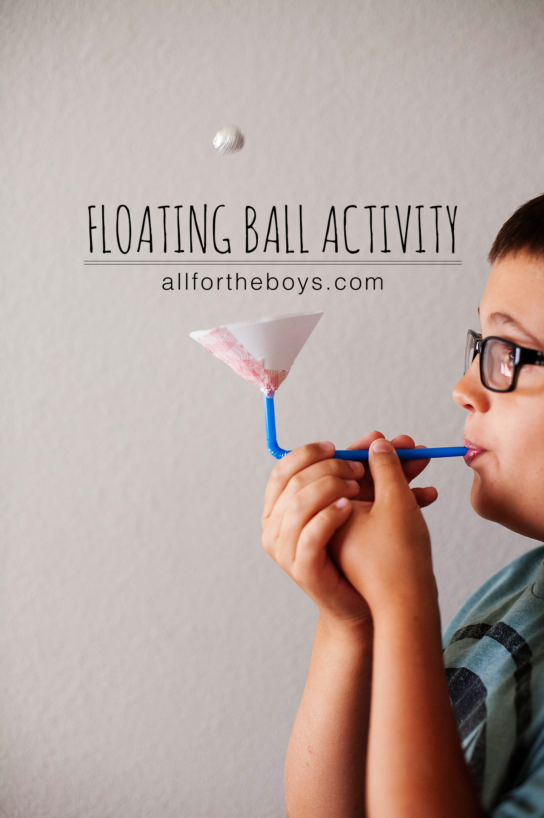

In this activity the students will be using a straw, paper cone, tape and a pom-pom ball to practice taking a deep breath and blowing our their breath. The goal of the activity is to build their air current apparatus and keep the pom-pom ball floating in the air current.

Students will first take their paper circle and overlap the cut edge to form a cone. They should then tape the cone in place, using the tape provided.

Next, they will tape the cone to the end of the straw on the bent side. Now, they can take the pom-pom and place it inside the cone. Have the students try to make the pom-pom float in the air current made by their breath.

Science behind the floating ball experiment

[https://www.stevespanglerscience.com/lab/experiments/floating-ping-pong-ball/#:~:text=The%20Floating%20Ping%20Pong%20Ball%20is%20a%20wonderful%20example%20of,%2C%20like%20airplanes%2C%20to%20fly.&text=The%20fast%20air%20moving%20that,than%20the%20surrounding%2C%20stationary%20air](https://www.stevespanglerscience.com/lab/experiments/floating-ping-pong-ball/#:~:text=The%20Floating%20Ping%20Pong%20Ball%20is%20a%20wonderful%20example%20of,%2C%20like%20airplanes%2C%20to%20fly.&text=The%20fast%20air%20moving%20that,than%20the%20surroundi).

Conversation starters and fun question ideas-

1. If you could go into any TV show – what show would you want to visit?

2. If you could only eat one fruit forever – what fruit would it be?

3. What are three words you would uses to describe yourself?

4. What do you think you are good at?

5. If you had to pick only one – would you want to be a great singer or a great

dancer?

6. If you went to another planet – what would you bring with you?

7. If you were a teacher what rules would you make?

8. If you could make your whole house out of food – what food would you use?

9. If you could have one super power what would it be?

10. If you could be an animal what would you be?

11. If you could paint the whole world – what color would you use?

**4:30**

 Wrap up and Goodbyes

* Updates and information- (Coach Makayla)
* Tutoring- Thursday 2:30pm  Reading pod- Monday 3:30(Coach Megan/Makayla)

**\*Coaches stay on for quick debrief**